CLASSIFYING ANIMALS

The order of classification for all living things is as follows.

Kingdom
Phylum
Class
Order
Family
Genus
Species

All members of a species have very similar characteristics. Generally, the scientific name includes the genus and species.

e.g. Dog - Canis familiaris.
Human - Homo sapiens.
Bottle-nose dolphin - Tursiops truncatus.

The basis for classifying animals involves observing many characteristics.

1. Cell and body structure.
2. Body covering.
3. Reproduction.
4. Movement.
5. Food-gathering methods.
6. Method of obtaining oxygen.
7. Body temperature.
8. Special senses.
9. Where an animal lives.

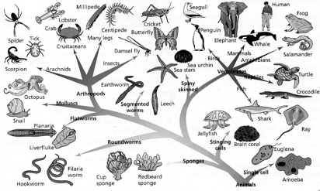
Invertebrates are classified into several groups called phyla.

Arthropods
• Have jointed body covering that supports and protects the body.
• There are several classes.

Insects
• 6 legs, 2 body parts (head, thorax, abdomen).
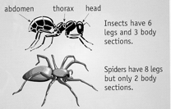
Arachnids
• 8 legs, 2 body parts.

e.g. Spiders, ticks, scorpions.

Crustaceans
• Breathe through gills.
• Most found in water (slaters live on land).

e.g. Crabs, crayfish, prawns.

Myriapods
• Have many legs.
• Centipedes (Chilopods) have 1 pair of legs per segment.
• Millipedes (Diplopods) have 2 pairs per segment.

Molluscs
• Most have a shell (slugs don't).
• Live in water or moist conditions.

e.g. Octopuses, squid, cuttlefish, snails.

Platyhelminthes
• Flat bodies.
• Sometimes parasitic.

Nematodes
• Round worms.
• Often parasitic.

Annelids
• Segmented worms.
• Found on land and in water.

Cnidarians
• Have stinging cells.

e.g. Jellyfish, anemones.

Echinoderms
• Spiny skin.
• Radial symmetry

e.g. Sea stars, sea urchins.

Protozoa
• Single celled animals.
• Live in moist environments.

Vertebrates are classified into 5 classes.

Fish
• Wet scales cover the skin.
• Live in water and breathe through gills.
• Changing body temperature.
• Lay eggs in water.

e.g. Sharks, rays, herring, snapper.

Amphibians
• Moist skin.
• Eggs laid in water.
• Larvae live in water and breathe through gills.
• Adults live on land and breathe through lungs.
• Changing body temperature.

e.g. Frogs, toads, salamander.

Reptiles
• Dry, scaly skin.
• Changing body temperature.
• Lay eggs with tough, flexible covering.

e.g. Turtles, snakes, lizards, crocodiles.

Birds
• Constant body temperature.
• Have feathers.
• Breathe through lungs.
• Lay eggs with hard outer shell.

e.g. Penguins, seagulls, albatross.

Mammals
• Constant body temperature.
• Have hair or fur covering the skin.
• Breathe through lungs.
• Most give birth to live young and feed them on milk.

e.g. Humans, whales, dolphins, dogs, cats.
Below is a key that can be used to classify animals according to their structure and function.

